Linked Queries

Requirements

Note: It is possible to mix LinkedQueries and normal Queries in the same query def or method file, however this is not recommended or supported and may produce unexpected results.

Currently the in XML->Database mapping part of server side framework is restrictive the way that SQL queries are executed. Although the developer is essentially able to write any SQL that is required, the SQL will still be executed as a hierarchy of small SQL queries. I.e. within a query definition file exists a hierarchy of pivot nodes and the execution of select statements will start at the top of the hierarchy and work down the structure in a recursive manner. This has the effect of a parent query determining the number of times a child query gets executed. A child query will be executed once for each row in the result set in the parent query. This can lead to a very large number of queries being executed. In situations where the number of rows returned by the parent query is very large and the number of rows returned by the child query is relatively small, the interaction between the application server and the database becomes highly inefficient. It is therefore necessary to allow developers to create configurations that will execute de-normalised queries and handle the collapsing of the results into the hierarchical XML structure.

The Theory
In understanding when and how to use Linked Queries is important to first understand the query definition as a description of the relationships between the objects that make up a given entity. Consider the following Case entity below:
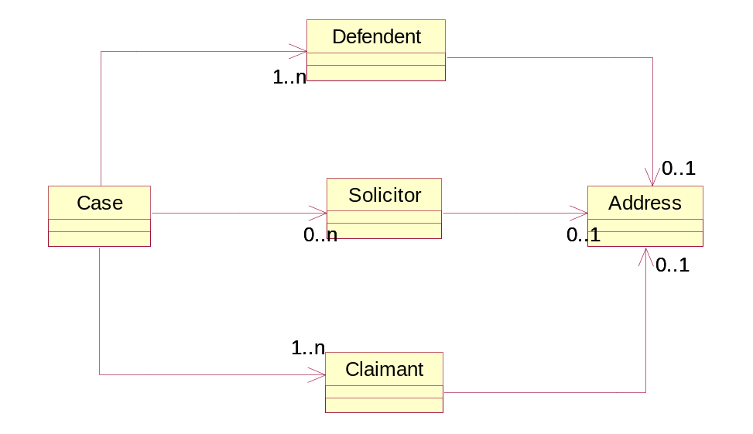

There are a number of objects that have different relationships which each other. However there are some important points to draw from the diagram. There is a single “root” object Case, which has relationships to 3 other object each with a cardinality greater than 1. I.e. in Java terms it contains 3 collections of related objects. Currently in the framework to load a group of Case entities it would first select all of the Case objects then for each case object execute a select for each of the Defendant, Solicitor and Claimant.

As mentioned previously this approach turns out to be inefficient, as the number of queries executed to load the list of entities increases in proportion to the number of “root” objects within the system. When getting lists of entities from the system it is required that the number of queries remain as constant as possible.

The most obvious solution to this problem is to create a single large de-normalised query that returns all of the data required to satisfy all of the objects, and this is possible in many use cases, however with the situation presented here it is not efficient to do that either. This is because the 3 collection although all apply to same Case do not have any relationship with each other therefore a single query to bring back all of the information, would return far more rows than required as rows returned would include the Cartesian product of the Solicitor, Defendant and Claimant.

The solution provided by the framework endeavours to find a middle ground between these two extremes. Firstly we make a few assumptions about the structure of entities:

- It is possible to relate all objects in the entity back to the root object via some form of SQL where clause.
- All objects will have a unique key consisting of one or more non-null column values.
- The root object can be constrained by some criteria and given assumption 1. this criteria may be applied to all objects within the entity.

Given these assumptions we start with the premise that we will execute a query once for each object within a given entity and aggregate the results together in memory. However this on its own will still be less than optimal. This will result in 7 separate SQL select calls to the database (the address object will require 3 separate queries for is it related to by 3 different parent objects). Even though a single de-normalised query is undesirable in this case, it would be advisable to be able to do a level of de-normalisation. The optimal situation would be to have each address fetched with the Solicitor, Claimant or Defendant. Also one of the child collections of the Case object could be fetched during the query for the Case.

Linked Joins
The solution to this problem is to extend the structure of the query definition specification to allow developers to specify queries that will execute in a de-normalised manner.

This has prompted the creation of a number of new tags to deal with this situation. The 2 tags are LinkedJoin & LinkedSQL. Examples of the usage of these tags is shown below.

<Query pivotNode="/Cases/Case" tables="c cts">
<LinkedJoin key="C.CASE_NUMBER" type="root">
<Join>
CTS.CODE = C.ADMIN_CRT_CODE
</Join>
</LinkedJoin>
<OrderBy>C.CASE_NUMBER ASC</OrderBy>
<Modify notModifable="true">
</Modify>
</Query>

<Query pivotNode="/Cases/Case/Parties/ClaimantParties/Claimant" tables="p cpr">
<LinkedJoin key="CPR.PARTY_ID" type="sub">
<Parent key="C.CASE_NUMBER" tables="C"/>
<Join>
CPR.CASE_NUMBER = C.CASE_NUMBER AND
CPR.PARTY_ROLE_CODE = 'CLAIMANT' AND
P.PARTY_ID = CPR.PARTY_ID
</Join>
</LinkedJoin>
</Query>

<Query pivotNode="/Cases/Case/Parties/DefendantParties/Defendant" tables="p cpr">
<LinkedJoin key="CPR.PARTY_ID" type="query">
<Parent key="C.CASE_NUMBER" tables="C"/>
<Join>
CPR.CASE_NUMBER = C.CASE_NUMBER AND
CPR.PARTY_ROLE_CODE = 'DEF' AND
P.PARTY_ID = CPR.PARTY_ID
</Join>
</LinkedJoin>
</Query>

<Query pivotNode="/Cases/Case" tables="c cts">
<LinkedSQL key="C.CASE_NUMBER" type="root">
<SQL>
SELECT
C.ADMIN_CRT_CODE AS "C.ADMIN_CRT_CODE", C.CASE_NUMBER AS "C.CASE_NUMBER",
C.CASE_TYPE AS "C.CASE_TYPE", C.STATUS AS "C.STATUS",
CPR.CASE_PARTY_NO AS "CPR.CASE_PARTY_NO",
CPR.PARTY_ID AS "CPR.PARTY_ID",
CTS.CODE AS "CTS.CODE", CTS.NAME AS "CTS.NAME",
P.PARTY_ID AS "P.PARTY_ID",
P.PERSON_REQUESTED_NAME AS "P.PERSON_REQUESTED_NAME",
C.CASE_NUMBER || C.CASE_TYPE AS "C.CASE_EXTRA",
CPR.ORA_ROWSCN AS "CPR_ORA_ROWSCN", C.ORA_ROWSCN AS "C_ORA_ROWSCN",
P.ORA_ROWSCN AS "P_ORA_ROWSCN", CTS.ORA_ROWSCN AS "CTS_ORA_ROWSCN"
FROM
CASE_PARTY_ROLES CPR, CASES C,
PARTIES P, COURTS CTS
WHERE
(CTS.CODE = C.ADMIN_CRT_CODE) AND
(CPR.CASE_NUMBER = C.CASE_NUMBER AND
CPR.PARTY_ROLE_CODE = 'CLAIMANT' AND
P.PARTY_ID = CPR.PARTY_ID)
ORDER BY
C.CASE_NUMBER ASC
</SQL>
</LinkedSQL>
</Query>

It is obvious from the configuration information specified here that the configuration for Linked Joins is more complex that for the standard types of Joins. There are a number of additional attributes and elements required for a given pivot node. Essentially a linked node will wrap a Join or SQL element in a LinkedJoin or LinkedSQL element.

There are two common attributes present for linked queries, key and type. Both are important for correct execution of Linked Queries. The key is space separated list of columns that make up a unique identifier for the given pivot node. The framework uses this key collapse the de-normalised query where necessary. The type defines how the query will operate. There are three types of Linked Query root, query and sub. The root and query types work in a similar they represent and actual query to be executed. Where as the sub query work quite differently. The purpose of the sub type is to allow queries that exist as child nodes to be absorbed into their parent node and be executed as part of a larger de-normalised query.

Each of the 3 types of query has a number of rules that it must obey:

- A root node may not be the child of another root.
- The sub and query nodes must define the appropriate Parent elements.
- A root or query node may not have more than sub node child at the same level.
- All sub and query nodes must include joins the columns defined by their Parent elements.
- The query that gets executed at the root node must return all of the objects that are required in the resulting XML. This is important when considering child sub nodes as all joins that represent a 0..n relationship must be expressed as an outer join. Failing to do this may inadvertently remove root objects from the resulting XML.

Defining Parents
The most import part of Linked Queries is concept of defining the Parent elements. This is the essence of “Linked” portion of this system. A sub or query element must contain a Parent element for every node that is a ancestor of this node listed in order from the top down. E.g. if a sub node is a child of a child of a root node and the root node’s key is “C.CASE_NUMBER” and is parent’s key is “P.PARTY_ID P.PARTY_TYPE” (i.e. a composite key), then its parent element would look as follows:

…
<Parent key=”C.CASE_NUMBER” tables=”C”/>
<Parent key=”P.PARTY_ID P.PARTY_TYPE tables=”P”/>
…

These values will be included in the select statement created by the framework so within the join statement for the pivot there must be a join from the table that contains the key column for this node to the tables containing the parent keys.

Linked SQL
Also the ability for the developer to write full SQL blocks is supported in this environment also. However there are number of subtleties to bear in mind.

- Nodes of type sub may not be LinkedSQL nodes.
- The join clause of child sub nodes of a LinkedSQL node will not be executed. Therefore the developer must manually include the SQL for any sub node within a LinkedSQL node.
- The SQL must return all key and parent key columns specified by the node.

Constraints
Constraints can be defined in the exact same way that they are defined using current joins. However there is a special case that happens when a user defines a constraint on a root node. The framework will automatically cascade that constraint onto every query node that is a descendent of the root node.

How it works
The Linked Query mechanism will operate in the following manner. When a request is made the system will walk the mapping DOM specified in the map file in much the same manner as the existing system. As it encounters an element that contains a pivot node it will execute the SQL for that pivot node. However in the case of a linked join it will indicate that the result for that pivot node may be cached. All of the results returned are placed in a map indexed by the parent key columns (the root will only have a single key in this map). Each value of the map will contain a list of the object instances that occur for the specified parent. As is passes through each pivot node it will iterate through the instances at that setting each into the current context. When encountering child nodes, they will lookup the parent key from supplied context.

Other Information
- Order by clauses are supported in LinkedJoin nodes.
- Page Controller elements are not supported in LinkedJoin nodes.
- Joins and Linked Joins may be mixed in the same query definition file, but should be use with caution.
- Context variables are not support when using only Linked Joins. They may only be use if they are a child of a standard Join node.

